MATERIAL MANAGEMENT -MAIN WORKFLOW

**IMPLEMENTATION PROCESS**

**CONFIGURATION PROCESS**

**TESTING**

**CUTOVER ACTIVITY**

**KNOWLEDGE TRANSFER**

**GO LIVE & SUPPORT/ HYPERCARE**

ASAP METHODOLOGY

1. PROJECT PREPARATION

2. BUSINESS BLUEPRINT

3. REALISATION – Setting up system configuration

5. GO LIVE & SUPPORT

Manufacturing Industry business workflow

No

Yes

Quality Testing

No

Yes

No

Yes

Check Final product Inventory

Invoice Generation

Final Product

Raw Materials Availability in production INV

Customer Delivery

Received it as expected in all aspects

Manufacturing

Procurement team finds vendor to buy

Planning

Order By Customer

**Document preparation for the above flowchart**

1. The customer places an order for a product.

2. The system checks the availability of the final product in inventory.

3. If the product is available, it is delivered directly to the customer.

4. If the product is not available, the process moves to the planning stage.

5. In the planning stage, the system checks for raw material availability in production inventory.

6. If raw materials are available, the manufacturing process begins.

7. If raw materials are not available, the procurement team finds a vendor to purchase them.

8. Once the materials are received, they are verified to ensure they meet quality expectations.

9. After successful approval, manufacturing of the final product is carried out.

10. The manufactured product undergoes quality testing.

11. If the product passes quality testing, the invoice is generated as per Country’s economy.

12. If the product fails quality testing, it is sent back to Manufacturing /service unit to fix the issues.

13. Then product moves to the finished product inventory/Showroom after generating the bill.

14. Finally, the product is delivered to the End Customer.

**Example plant for Phone Manufacturing:**

Step 1: Need to find Customer Needs in market.

Step 2: Need to find the resource to do R&D and designing the Phone.

Step 3: Need Approval from Head office to start the production

Step 4: Need to find/buy the raw materials from right vendor. (Outer Frame, Glass, Semi conductors and Integrated circuits, Battery etc.

Step 5: Once everything is available, manufacturing can be carried out.

Step 6: The manufactured product undergoes quality testing.

Step 7: If the product passes quality testing, the invoice is generated .

Step 8: If the product fails quality testing, it is sent back to Manufacturing /service unit to fix the issues.

Step 9: Finally, the product is delivered to the End Customer after generating the bill.

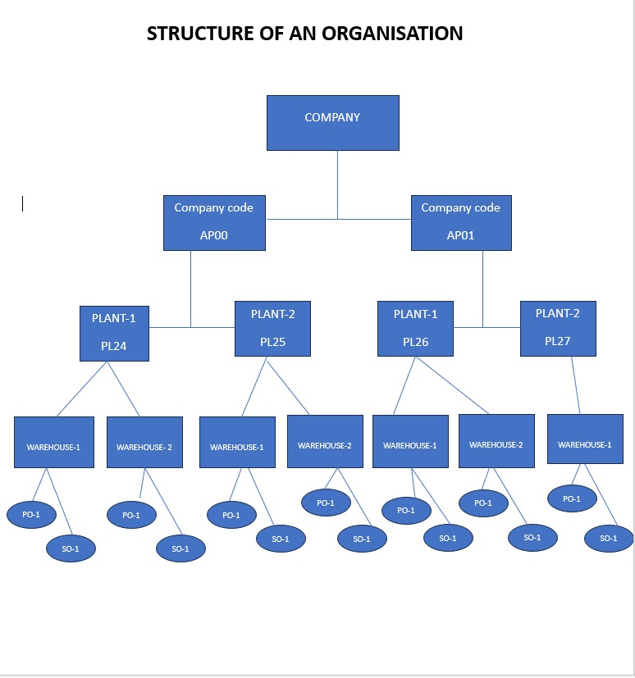

P2P / PTP Cycle

Procurement work flow

# SOFTWARE NAVIGATION

Basic Shortcut Keys

1. /N – Close
2. /O – Minimise and open next tab
3. To copy value from report table

* Select the value to be copied
* Select Ctrl+Y
* Select Ctrl+C and then Ctrl+Y

1. T Codes :

* SPRO - OMSR - EC01 - OX10 – OX09 – OX17
* SE16N - MMBE – MARA – MARB – MARC - MARD
* EKPO – EKKO – ME5A – ME2N - OMSF

# SAP MM Configuration – Real-Time Project Flow

Project Kickoff & Requirement Gathering  
(Understand client’s procurement and inventory processes)

Define Enterprise Structure  
(Create Company Code, Plant, Storage Location, Purchasing Org)

Assign Enterprise Structure  
(Link structures: Plant to Company Code, etc.)

Material Master Configuration  
(Define Material Types, Number Ranges, Field Selection)

Vendor Master Configuration  
(Define Account Groups, Number Ranges)

Purchasing Configuration  
(Define PO Document Types, Pricing Procedures, Release Strategies)

Integration Testing  
 (Simulate PR → PO → GR → IR end-to-end)

Inventory Management Setup  
 (Movement Types, Valuation Areas, Tolerances)

Go-Live & Support  
(Monitor transactions and fix post-live issues)

Training and UAT  
(User training + Client testing with real data)

# MRP - Material Requirements Planning

In SAP, MRP is the **automated process** used to:

**Plan what materials are needed, in what quantity, and when — so that production or sales never gets delayed.**

It checks:

* What materials are needed
* How much stock is available
* What’s already ordered
* What needs to be ordered or produced

**Purpose of MRP:**

To make sure that:

* Raw materials are available for **production**
* Finished goods are available for **sales**
* Inventory is kept at **optimum levels** (not too much, not too little)

**What does MRP generate?**

After you run MRP, SAP may create:

* **Purchase Requisition** (to buy raw materials)
* **Planned Order** (to produce materials)
* **Schedule Lines** (for scheduling delivery)
* **MRP Lists** (to review needs)

# MRP Types:

| **Type** | **Meaning** |
| --- | --- |
| PD | Standard MRP (Net Requirements Planning) |
| VB | Reorder Point Planning |
| V1 | Automatic reorder point |
| ND | No MRP (manual control) |

# Core Elements in SAP MRP:

| **Element** | **What it means** |
| --- | --- |
| **Material Master** | Must be MRP enabled (MM02) |
| **MRP Type** | Ex: PD (Standard MRP), VB (Reorder Point) |
| **Plant & Storage Location** | MRP runs at plant level |
| **Procurement Type** | F = External (Buy), E = In-house (Make) |
| **Lot Size** | How much to order/produce at a time |
| **MRP Controller** | Responsible planner ID |

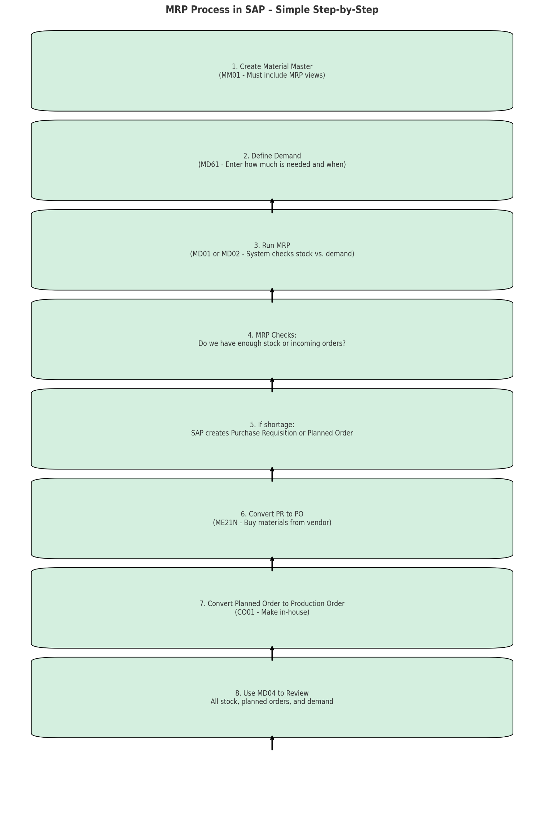

**Summary Diagram (Conceptual Flow)**

1. **Material Setup (MM01/MM02):**
   * MRP views established (MRP Type, Lot Sizing, Safety Stock, etc.)
2. **Define Demand (MD61):**
   * Enter forecast or actual demand data.
3. **MRP Run (MD01/MD02):**
   * System calculates net requirements.
4. **Review Results (MD04):**
   * Check stock, PRs, and planned orders.
5. **Order Conversion:**
   * PR → PO (ME21N) or Planned Order → Production Order (CO01)
6. **Monitor and Adjust:**
   * Regularly update planning based on actual performance.

# Comparison between

# MRP Procedure fields and Lot Size fields

**MRP Procedure Fields (in MRP1 View)**

| **Field** | **Description** | **Example Values** |
| --- | --- | --- |
| **MRP Type** | Controls whether and how the material is planned (e.g., MRP, reorder point). | PD (MRP), VB (Reorder Point), ND (No Planning) |
| **Reorder Point** | Stock level that triggers procurement (used in Reorder Point Planning). | E.g., 100 units |
| **Planning Time Fence** | Time during which system won't automatically change procurement proposals. | E.g., 15 days |
| **MRP Controller** | Responsible person or group for MRP; used for reporting and exception messages. | E.g., 001 |

**Lot Size Fields (in MRP1 / MRP2 View)**

| **Field** | **Description** | **Example Values** |
| --- | --- | --- |
| **Lot Size** | Controls how much is to be procured or produced at once. | EX (Lot-for-lot), HB (Reorder Point Lot), FX (Fixed Lot Size) |
| **Minimum Lot Size** | Minimum quantity to be ordered/produced. | E.g., 50 units |
| **Maximum Lot Size** | Maximum quantity to be ordered/produced. | E.g., 500 units |
| **Fixed Lot Size** | Fixed quantity to be ordered every time (used with FX lot size). | E.g., 100 units |
| **Rounding Value** | System rounds order quantities to this multiple. | E.g., 10 (rounds to nearest 10) |

# Key Differences

| **Aspect** | **MRP Procedure Fields** | **Lot Size Fields** |
| --- | --- | --- |
| **Purpose** | Controls *how and when* planning happens | Controls *how much* to procure/produce |
| **Planning Trigger** | Defines if planning is automatic or manual | Defines quantity decision logic |
| **Tied to Stock Level** | Yes, in cases like reorder point | No, based on planning output |
| **Affects Procurement Quantity?** | Indirectly | Directly |

# Transferring details technically from table to form

Eg:

For Material: Pass Value EKPO-EBELN to get value from EKPO -MATNR